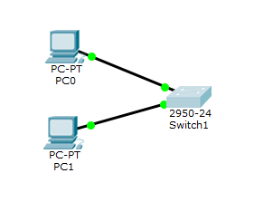

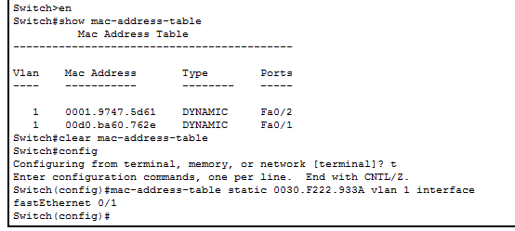

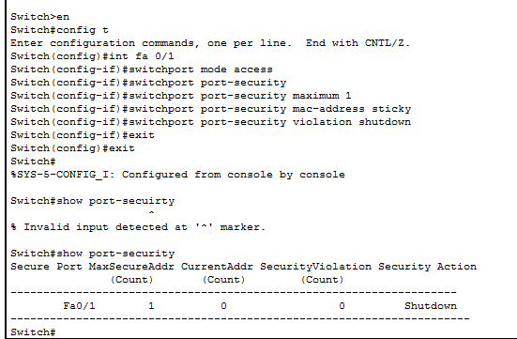

ping 10.0.0.2

Pinging 10.0.0.2 with 32 bytes of data:

Reply from 10.0.0.2: bytes=32 time=1ms TTL=128

Reply from 10.0.0.2: bytes=32 time=0ms TTL=128

Reply from 10.0.0.2: bytes=32 time=0ms TTL=128

Reply from 10.0.0.2: bytes=32 time=0ms TTL=128

Ping statistics for 10.0.0.2:

Packets: Sent = 4, Received = 4, Lost = 0 (0% loss),

Approximate round trip times in milli-seconds:

Minimum = 0ms, Maximum = 1ms, Average = 0ms